Call the function by using the functional component method.
// Example of Calling the function using component call
function Comp() {
return (<h1> As usual we can call the function using component call</h1>);
}
const root = ReactDOM.createRoot(document.getElementById('root'));
root.render(<Comp />);
Now, We will use the functional component method to create a program and see how functional components render the component in the browser.
Steps to create the React Application
Step 1: Create React Project
npx create-react-app myreactapp
Step 2: Change your directory and enter your main folder charting as
cd myreactapp
Project Structure:
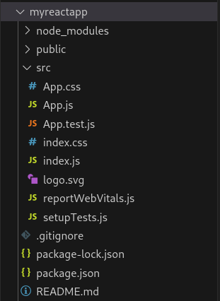
Example 1: This example demonstrates the creation of functional components.
//Filename - App.js

import React from 'react';
import ReactDOM from 'react-dom';

const Demo=()=>{return <h1>Welcome to React Training class</h1>};
export default Demo;

// Filename - index.js

import React from "react";
import ReactDOM from "react-dom";
import Demo from "./App";

const root = ReactDOM.createRoot(
document.getElementById("root")
);
root.render(
<React.StrictMode>
<Demo />
</React.StrictMode>
);
Step to run the application: Open the terminal and type the following command.
npm start
Output: Open the browser and our project is shown in the URL http://localhost:3000/

// dynamically incrementing a counter using button click
import React from "react";
import ReactDOM from "react-dom";

const rootElement = document.getElementById("root");
let counter = 0;
const handleClick = () => {
counter++;
console.log("counter", counter);
renderContent();
};

const renderContent = () => {
const content = (
<div>
<button onClick={handleClick}>Increment counter</button>
<div>Counter value is {counter}</div>
</div>
);

ReactDOM.render(content, rootElement);
};

renderContent();

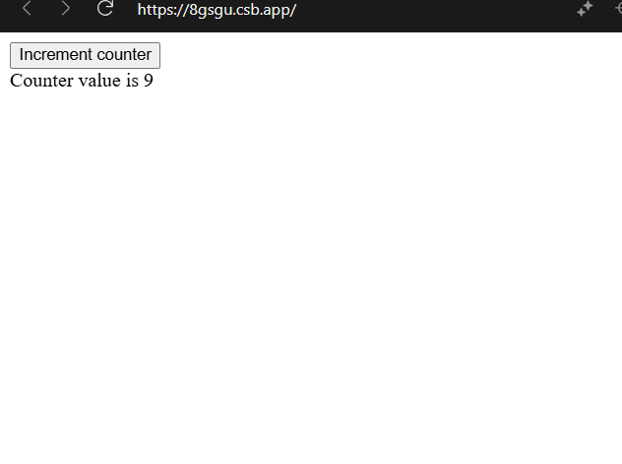
Right click in the page -> inspect element -> Elements tab and watch the value getting updated dynamically.
But still, it's not feasible to call the renderContent function every time we want to update the UI. So React added the concept of State.

What are React Hooks
Using React Hooks we can use state and lifecycle methods inside functional components.
code to use hooks. The useState hook returns an array whose first value is the current value of the state. The second value is the function which we will use to update the state similar to the setState method.
React hooks are functional components with added state and lifecycle methods.

import React, { useState } from "react";
import ReactDOM from "react-dom";

const App = () => {
const [counter, setCounter] = useState(0);

return (
<div>
<div>
<p>Counter value is: {counter} </p>
<button onClick={() => setCounter(counter + 1)}>Increment</button>
</div>
</div>
);
};

ReactDOM.render(<App />, document.getElementById("root"));

As you can see, using React hooks makes the code a lot shorter and easier to understand.
Let’s understand the above code.
- To use the useState hook, we need to import it as we have done it in the first line.
- Inside the App component, we are calling useState by passing 0 as the initial value and using destructuring syntax. We stored the array values returned by useState into counter and setCounter variables.
- It's a common convention to prefix the function name used to update the state with the set keyword as in setCounter.
- When we click the increment button, we are defining an inline function and calling the setCounter function by passing the updated counter value.
- Note that as we already have the counter value, we have used that to increment the counter using setCounter(counter + 1)
- Since there is a single statement in the inline on click handler, there is no need to move the code into a separate function. Though you can do that if the code inside the handler becomes complex.

Multiple hooks in a functional component

import React, { useState, useEffect } from "react";
import ReactDOM from "react-dom";

const App = () => {
const [counter, setCounter] = useState(0);
const [username, setUsername] = useState("");

useEffect(() => {
console.log("useEffect executed");
});

return (
<div>
<div>
<p>Counter value is: {counter} </p>
<button onClick={() => setCounter(counter + 1)}>Increment</button>
<br />
<br />
Name{" "}
<input
type="text"
name="username"
value={username}
placeholder="Enter your name"
autoComplete="off"
onChange={event => setUsername(event.target.value)}
/>
<br />
{username}
</div>
</div>
);
};

ReactDOM.render(<App />, document.getElementById("root"));

